 



Database Programming with SQL

* 1. : Using ROLLUP and CUBE Operations and GROUPING SETS Practice Activities

# Objectives

* + - Use ROLLUP to produce subtotal values
    - Use CUBE to produce cross-tabulation values
    - Use GROUPING SETS to produce a single result set
    - Use the GROUPING function to identify the extra row values created by either a ROLLUP or CUBE operation

# Vocabulary

Identify the vocabulary word for each definition below.

|  |  |
| --- | --- |
| **ROLLUP** | Used to create subtotals that roll up from the most detailed level to a grand total, following a grouping list specified in the clause |
| **CUBE** | An extension to the GROUP BY clause like ROLLUP that produces cross-tabulation reports |
| **GROUPING SETS** | Used to specify multiple groupings of data |

# Try It / Solve It

1. Within the Employees table, each manager_id is the manager of one or more employees who each have a job_id and earn a salary. For each manager, what is the total salary earned by all of the employees within each job_id? Write a query to display the Manager_id, job_id, and total salary. Include in the result the subtotal salary for each manager and a grand total of all salaries.

SELECT manager_id, job_id, SUM(salary) "total salary", GROUPING(manager_id), GROUPING(job_id)

FROM employees

GROUP BY ROLLUP(manager_id, job_id);

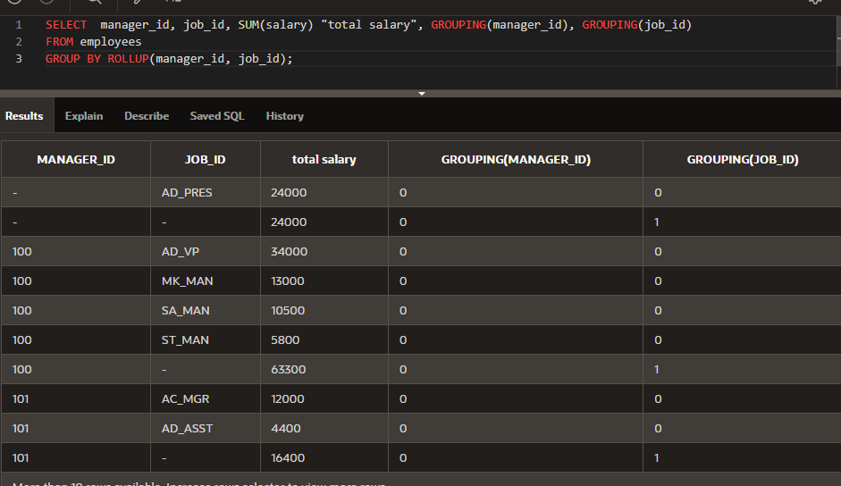

1. Amend the previous query to also include a subtotal salary for each job_id regardless of the manager_id.

SELECT manager_id, job_id, SUM(salary) "total salary", GROUPING(manager_id), GROUPING(job_id)

FROM employees

GROUP BY CUBE(manager_id, job_id);

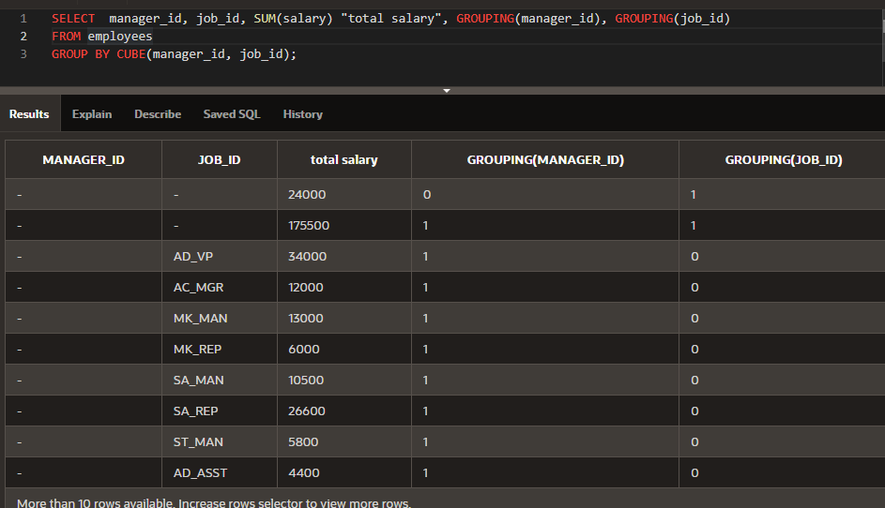

1. Using GROUPING SETS, write a query to show the following groupings:
   * department_id, manager_id, job_id
   * manager_id, job_id
   * department_id, manager_id

SELECT department_id, manager_id, job_id, SUM(salary) "total salary", GROUPING(department_id), GROUPING(manager_id), GROUPING(job_id)

FROM employees

GROUP BY GROUPING SETS((department_id, manager_id, job_id), (manager_id, job_id), (department_id, manager_id));

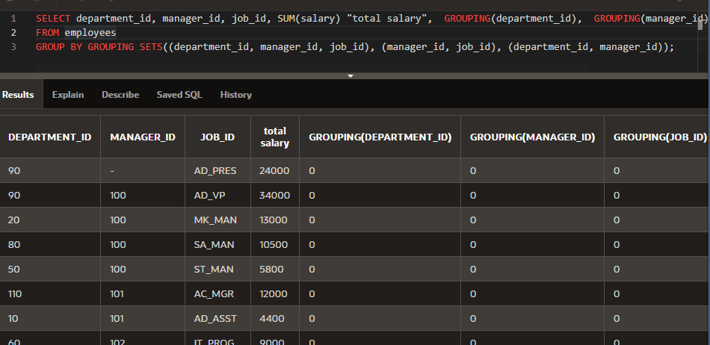

Copyright © 2020, Oracle and/or its affiliates. All rights reserved. Oracle and Java are registered trademarks of Oracle and/or its affiliates. Other names may be trademarks of their respective owners.